Christopher Wilson
7/6/2026
CS-660 Module One Activity

Identify key structural and stylistic differences in each code sample. Include the following:
- How control flow, data handling, and abstraction are implemented
The imperative code uses a for loop and if statements to go through each grade one at a time. It stores data such as total, count, highest, lowest, and passing count, which are updated as the program runs. All of the logic is contained inside the analyze_grades function, so there is little abstraction. Compared to the other code samples, it is the easiest to follow because it follows a clear step-by-step order. However, because everything is in one function, it would make it harder to add new features and maintain the code. The functional code uses functions like map(), filter(), reduce(), and lambda functions instead of writing loops and updating variables. Each function only does one task, such as calculating the average or finding the highest grade. The functions are then combined to make the final report. Compared to imperative code, it has more abstractions because the calculations are broken up into smaller, reusable functions instead of a single large function. This makes it easier to add more features and maintain the code because you only need to make a new function without needing to change much of the existing code. However, compared to imperative code, it is harder to read because it uses functions like lambda along with map(), filter(), and reduce(), which can be more confusing to understand. Object-oriented code stores everything into a GradeAnalyzer class, where the grades are stored as part of the object, and each calculation uses its own method. Instead of one large function, each calculation is divided among methods such as get_average() and get_highest (), which then the print_results() method calls these methods to display the results. Compared to both imperative and functional code, it has a higher level of abstraction because it groups the data and the methods that work with the data into a single class. This makes the code more organized and easier to maintain because each method only performs a specific task. This makes it easier to add a new feature because you only need to add a new method that performs the new feature, which helps implement the feature without changing the existing code much. The main difference between functional and object-oriented code is how the program is organized. Functional programming organizes the program around functions that process data, while object-oriented programming organizes the program around objects and classes that store data and the methods that operate on it.
Explain how the structure of each code sample supported or hindered the modification.
Adding the median calculation code to the imperative code was easy because all of the logic was in one function. I only needed to add the code to sort the grades, calculate the median, and then print the result. While it was easy to add the median calculation, adding more features in the future would make the function more cluttered and harder to understand. Adding the code to the functional code was more difficult because it was harder to understand a lambda function compared to a regular function. However, it was easier to add in the calculation itself because I only needed to add the new function to the list of other analysis functions and just print it. Compared to the imperative code, I only changed the print function for the existing code, while for the imperative code, I needed to add a new variable, calculation, and the print function. The object-oriented code made it easy to make the modifications because I only needed to add a new method that calculates the median. It was a similar process to the functional code; It was much easier to write the code that calculates the median because it uses a normal method instead of a lambda function

Evaluate the maintainability of each code sample based on your modification experience.
After my modification experience, I would say the imperative code would be the hardest to maintain. Because all of the logic is contained in one function, adding new features requires changing multiple parts of the code. When implementing the median calculation, I had to add new variables, new calculations, and another print statement. As the code expands, it will become more difficult to maintain because the function will become longer, making the code look cluttered and harder to understand. Compared to the imperative code, the functional and object-oriented code are much easier to maintain because they are more modular. Instead of having all the logic in one place, the code is split into separate functions or methods, which allows new features to be added without heavily modifying existing code. This keeps the code more organized as it grows and improves readability, which also improves maintainability.
Evaluate the readability of each code sample based on your review and modifications.
After my modification experience, I would say that the imperative code was much more readable compared to the functional and object-oriented code. The imperative code was easy to read because the logic followed a clear step-by-step process. Because it was written in a single function, it’s easy to understand the code from start to finish. The functional code was moderately easy to read because each function had a single purpose. This makes it easy to understand what each function does. However, it was much harder to understand the flow of the program because the logic was split between multiple functions. It was also harder to understand the functions themselves because it uses lambda functions, which makes it hard to examine the inner workings of the functions. The object-oriented code was readable because, like the functional code, it splits the code into separate parts. In this case, the calculations are split into methods. Like the functional code, it splits the logic. It can be hard to understand the flow of the program because you have to look at multiple parts of the class to understand the full process.
Compare the provided code samples based on performance expectations.
Based on performance expectations, I would say the imperative code is likely the most efficient because it uses simple loops and updates variables directly in memory. This makes it fast since it avoids extra function or method calls and additional overhead. The functional and object-oriented versions require more function or method calls, which can cause some overhead. However, in this case, the dataset is very small, so there should be no noticeable performance difference between the three types of code.
Compare the provided code samples based on overall maintainability.
Based on overall maintainability, the imperative code would be the hardest to maintain. This is because the logic is all contained in one function. As more features are added to the code, the function becomes more cluttered, which would make it more difficult to read, making it harder to add, remove, or fix to maintain it. The functional code is much easier to maintain because it is modular, which allows me to add new functionality without having to change any of the existing code. Although the use of lambda functions and tools like map() and filter() makes it slightly harder to understand and modify. The object-oriented code is the easiest to maintain because, like the functional code, it breaks the code into smaller bits where each method holds a single calculation. Like the functional code, it allows me to add in new features without changing the existing code much, which improves the long-term maintainability.
Compare the provided code samples based on overall readability.
Based on overall readability, the imperative is the easiest to read because it follows a clear step-by-step process in a single function. However, the readability would be worse as the code expands, which means imperative code would be best for shorter simple programs. The functional code is moderately readable because each function is split, which means if I were to change a function, I would just have to look for the function and just change the code inside the function only. Even as the code expands, the readability would still be good because functions organize the code well. Object-oriented code also has a high overall readability because it splits the calculations. However, when reading both object-oriented code and functional code, you need to jump between functions or methods because the code is not streamlined, which can reduce the readability compared to imperative code. This would mean that both functional and object-oriented code are best used for longer and more complex code for maintainability and readability.

Program outputs
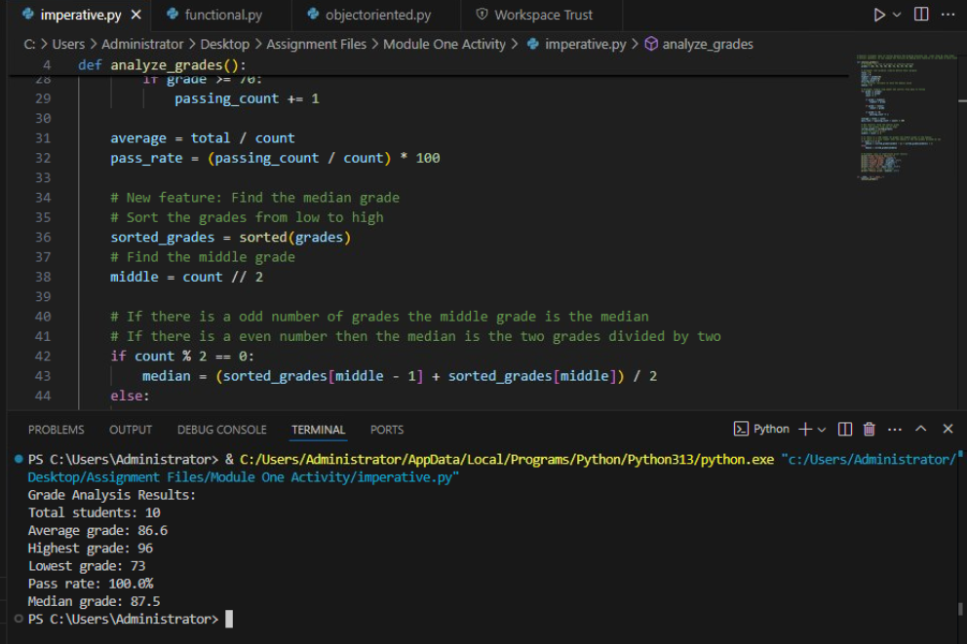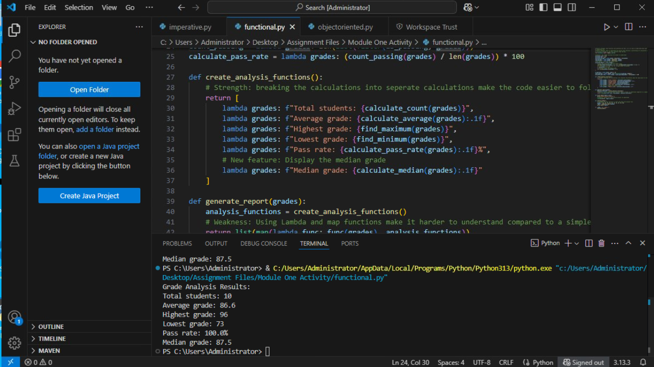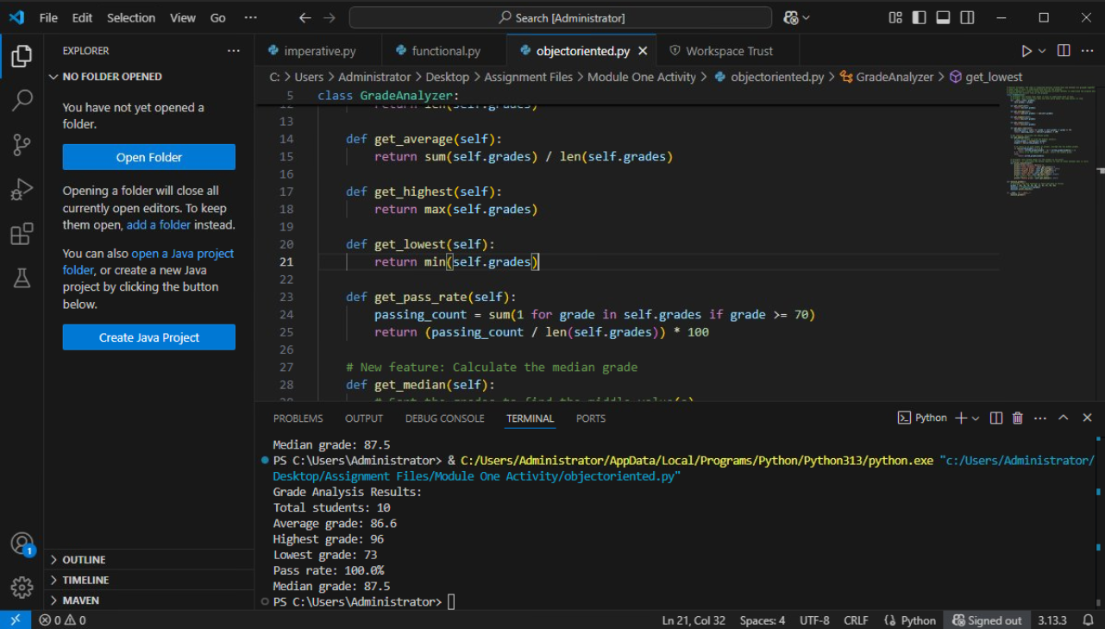

Sources
Functional Programming HOWTO — Python 3.10.0 documentation. (n.d.). Docs.Python.Org. https://docs.python.org/3/howto/functional.html
GeeksforGeeks. (2018, October 12). Introduction of Programming Paradigms. GeeksforGeeks. https://www.geeksforgeeks.org/system-design/introduction-of-programming-paradigms/
Python. (n.d.). 9. Classes — Python 3.8.4rc1 documentation [Review of 9. Classes — Python 3.8.4rc1 documentation]. Docs.Python.Org. https://docs.python.org/3/tutorial/classes.html
OpenAI. (2026). ChatGPT (July 6 version) [Large language model]. https://chat.openai.com/
Chatgpt used for debugging code and helping me understand lambda functions

